1.所有文本框及一级标题和iHP页面对齐标准，要立体好看的文本框和按钮

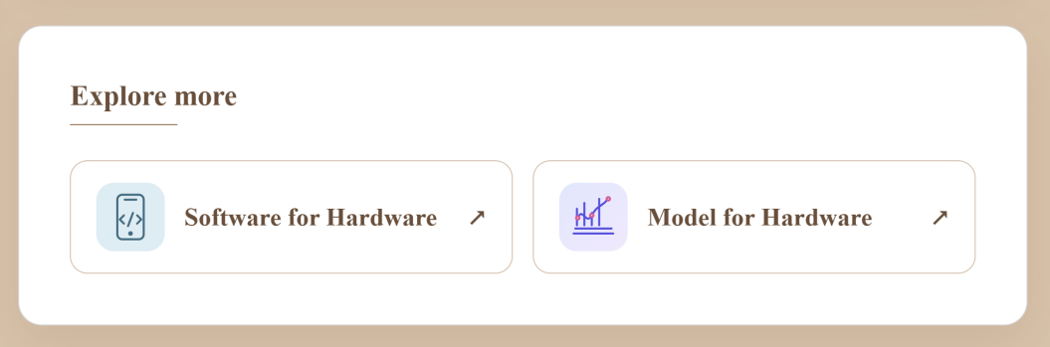
像这样：
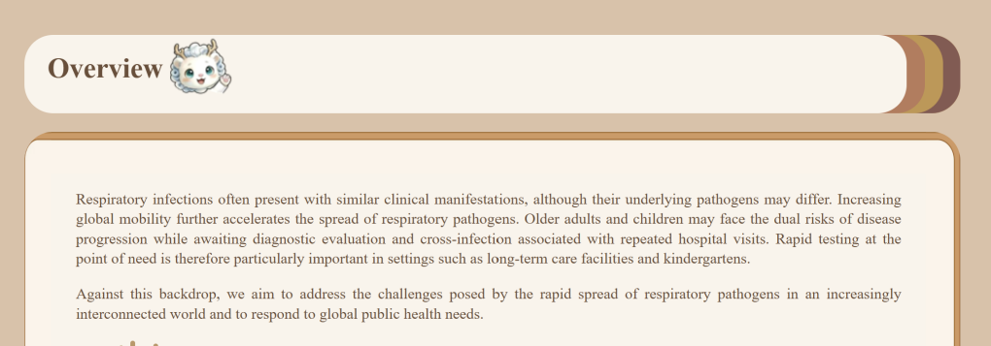
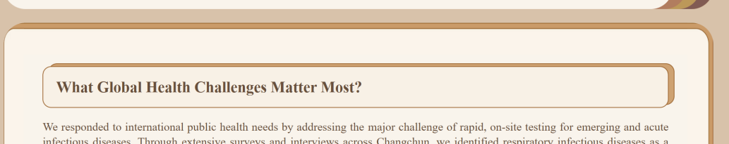

2.调整图片大小：
Figure 3. 6.7 太大了，和其他图片不协调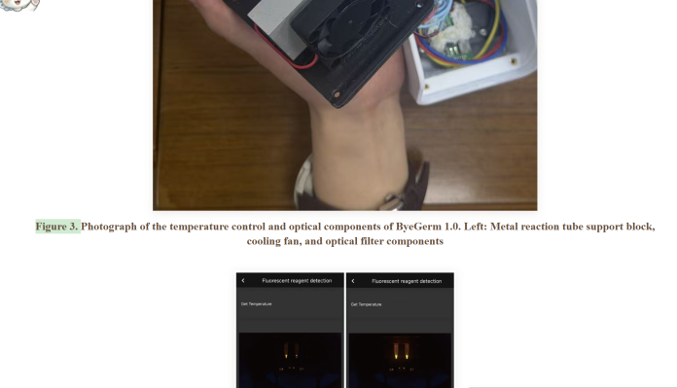
Figure 9.10 小了，拉大一些，可以和Fig16差不多
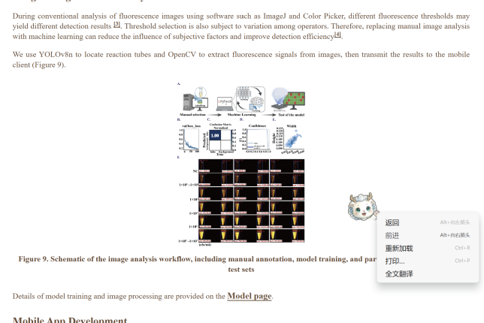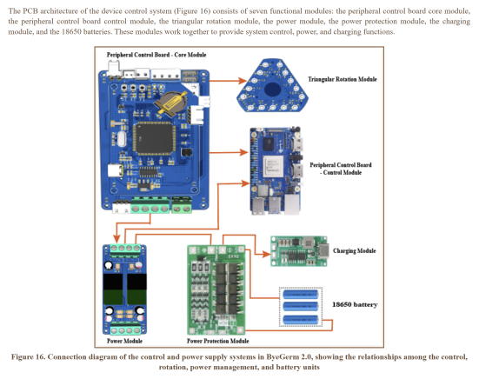
Figure 11 和上面的文本框长度对齐
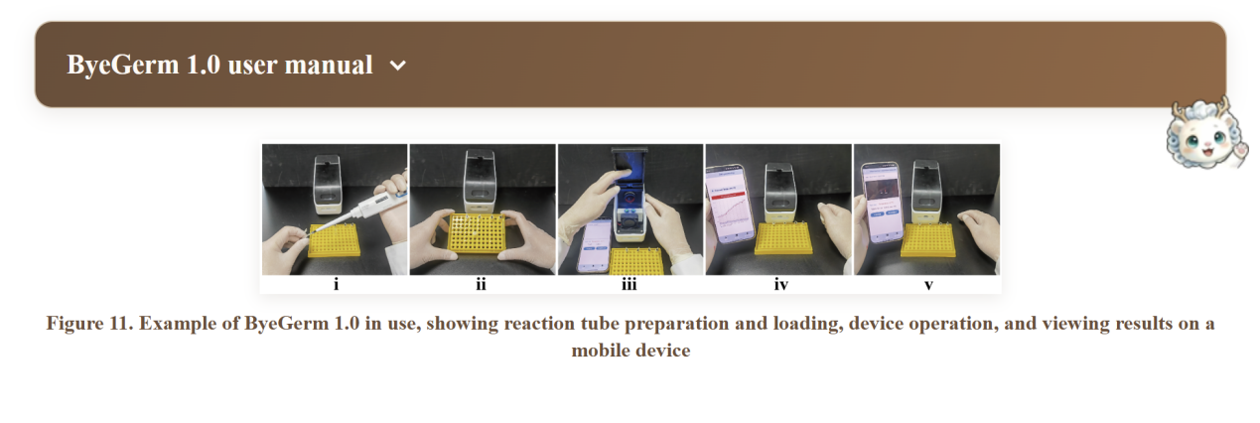
Figure13 缩小一些
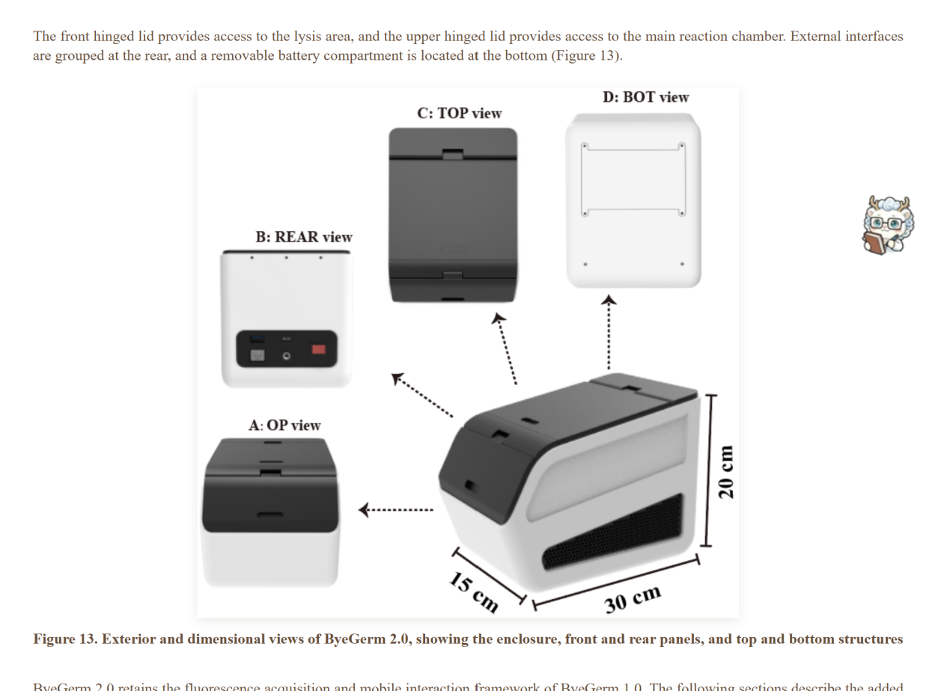
4.最后这部分内容替换
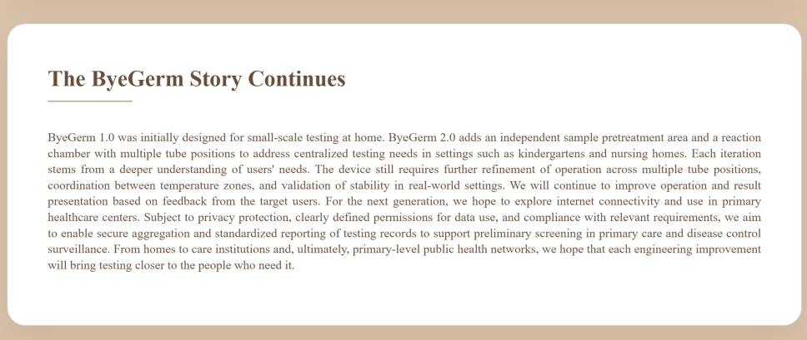
The ByeGerm Story Continues
From ByeGerm 1.0 to ByeGerm 2.0, we translated the requirements of synthetic biology detection workflows—controlled reaction temperatures, consistent fluorescence acquisition, and accessible result interpretation—into a portable platform integrating temperature control, imaging, image analysis, and a mobile interface. The first generation established a complete workflow from reaction management to fluorescence readout. In response to the need for centralized testing identified through consultations with frontline staff and caregivers in nursing homes and kindergartens, the second generation introduced an independent sample pretreatment area with two tube positions and a rotating reaction chamber with fifteen positions. These changes were accompanied by updates to image acquisition and result display across multiple tube positions. Each iteration demonstrates how needs identified in intended use settings informed concrete engineering decisions.
ByeGerm provides a practical hardware platform for running molecular detection assays and recording their outputs. Temperature control tests and comparisons of imaging distances helped refine reaction and imaging conditions. With the second-generation device, we demonstrated fluorescence readout for five pathogen assays, individual tube recognition across five positions, and data acquisition and result display on tested devices running four mobile operating systems. Together, these records support the platform’s functional feasibility under the tested conditions. They also connect reaction positions with fluorescence images and results displayed in the app, providing a traceable basis for further evaluation.
We also want other teams to understand and build upon this work. The modular structure, removable enclosure components, and consolidated interfaces facilitate assembly and maintenance. Published structural and circuit descriptions, reproduction guides, user manuals, and component cost breakdowns provide a foundation for rebuilding the device, selecting components, and adapting the design. By sharing our development process, test results, and the scope of current validation, we aim to reduce the information gaps and engineering barriers faced by teams developing portable fluorescence detection hardware, extending the value of ByeGerm to other synthetic biology projects.
Building on these achievements, we will further evaluate temperature uniformity across tube positions, coordination between heating zones, and reliability during extended operation. Hands-on testing with intended users will guide continued improvements in usability. With further validation and appropriate privacy safeguards, we also hope to explore secure connectivity and applications in primary healthcare settings. From small-scale testing at home to the centralized testing needs of care institutions, ByeGerm continues to pursue one goal: to provide synthetic biology detection with tools that are easier to use, portable, and open to continued improvement, bringing the technology closer to practical needs and the people it is intended to serve.

